# Final Report

## Notes

|  |  |  |
| --- | --- | --- |
| Presentation  Graph,  chart,  diagram | /ˌprez(ə)nˈteɪʃ(ə)n/  /ɡrɑːf/ /tʃɑːt/  /ˈdaɪəɡræm/ | the activity of formally presenting something (as a prize or reward);  a drawing intended to explain how something works; a drawing showing the relation between the parts |
| Trend  Trend analysis | /trend/  [tendency](javascript:;) [tide](javascript:;) [direction](javascript:;) | A general direction of change in a situation |
| substantial | /səbˈstænʃ(ə)l/ | won by a substantial margin  large in amount, value, or importance |
| To increase | Raising, growth, gain,  Enhancement;  Improve, accelerate;  Add, boost  incline | To get bigger or to make something become less in amount, size, or number |
| To decrease | Reduction, loos;  To cut down, fall off;  Shorten, weaken  decline | In opposite of increase |
| To remain  keep |  | To continue to be something or to stay in the same state or condition |
| To illustrate  Show  demonstrate | /tu ˈɪləstreɪt/ | To make the meaning of something clearer by using example, pictures, etc |
| etc  et cetera | / ˌet ˈsetərə / | So on and so forth |
| units | /ˈjuːnɪts/ | Imperial units 英制单元 |
| **conveys** | /kənˈveɪz/ | Express  show |

This graph illustrated the general trend of our sales for 2020. As you can see, there was a substantial rise in March and sales increased to nearly 250,000 units. Then, from April to August, sales decreased. Finally, sales leveled off and have remained near 100,100 units since October.

|  |  |  |
| --- | --- | --- |
|  |  | |
| Line graph | A line graph provides a means in which to compare two different types of information through showing how they are **similar** and how they are **differ**. This is performed through the use two lines each representing the two aforementioned pieces of information which are then charted along a numerical scale.  trend | |
| Bar graph | A bar graph is very similar to a line graph in the sense that it is designed to show different values of two or more subjects but instead of using lines it using **horizontal and vertical bars** that represent a different value. There are numbers along the side of a bar graph and they are scales identical to what would be found on a line graph. In a way, this type of graph is somewhat easier to read than a line graph and it **conveys** informational equally as well.  a graphical display of data using bars of **different heights.** | |
| Pie graph | to show differences between two separate subjects although it eschews the common linear style found in the two other graphs.  A pie chart is a very common type of graph that is in the shape of a **circle with the circle representing a collective of 100%.** Then, within the circle smaller **percentage portions** within the 100% will be presented in different colors. It is probably the easiest chart to read and is commonly used in marketing and business presentations. | |
|  |  | |
| Horizontal axis | /ˌhɒrɪˈzɒnt(ə)l/ | Horizontal line/direction  parallel to or in the plane of the horizon or a base line |
| Vertical axis | /ˈvɜːtɪk(ə)l/ | Vertical distribution  something that is oriented vertically;  a vertical structural member as a post or stake |
| Curve  Line, linear  percentage | /kɜːv/  /laɪn/ /ˈlɪniə(r)/  /pəˈsentɪdʒ/ |  |
| Bonus  Annual bonus  Bonus point | /ˈbəʊnəs/ | 奖金，津贴，红利；意外收获，额外好处  anything that tends to arouse;  an additional payment (or other remuneration) to employees as a means of increasing output |
| **Visual**  **Visualize**  **visualization** | /ˈvɪʒuəl/  /ˈvɪʒuəlaɪz/ /ˌvɪʒuəlaɪˈzeɪʃn/ | Data visualization  Flow visualization |
| Diagram  Chart  graph | /ˈdaɪəɡræm/ | Sequence diagram |
| **proficiency** | /prəˈfɪʃ(ə)nsi/ | Proficiency test熟练测验 |
| **Valid documentation** |  | 有效证件  Valid identity documents |
| **certification** | /ˌsɜːtɪfɪˈkeɪʃ(ə)n/ | Quality certification 质量认证 |

|  |  |  |
| --- | --- | --- |
| hint | /hɪnt/ | an indirect suggestion |
| prepositions | /ˌprepəˈzɪʃən/ | 介词；系词  a function word that combines with a noun or pronoun or noun phrase to form a prepositional phrase that can have an adverbial or adjectival relation to some other word |
| per se |  | In oneself  with respect to its inherent nature |
| inherent |  | Inherent quality  Inherent characteristic |

## Lesson slides and notes

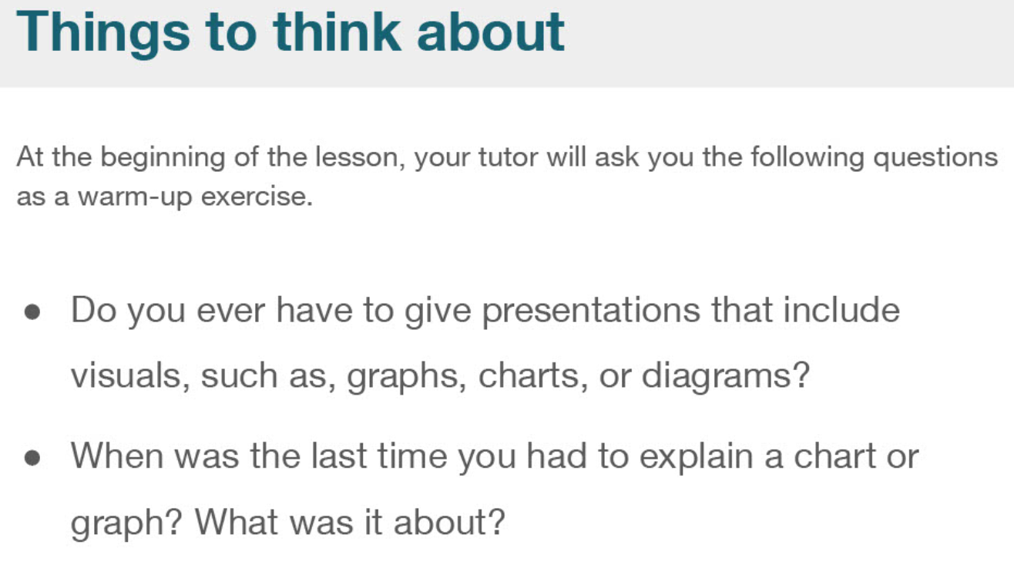

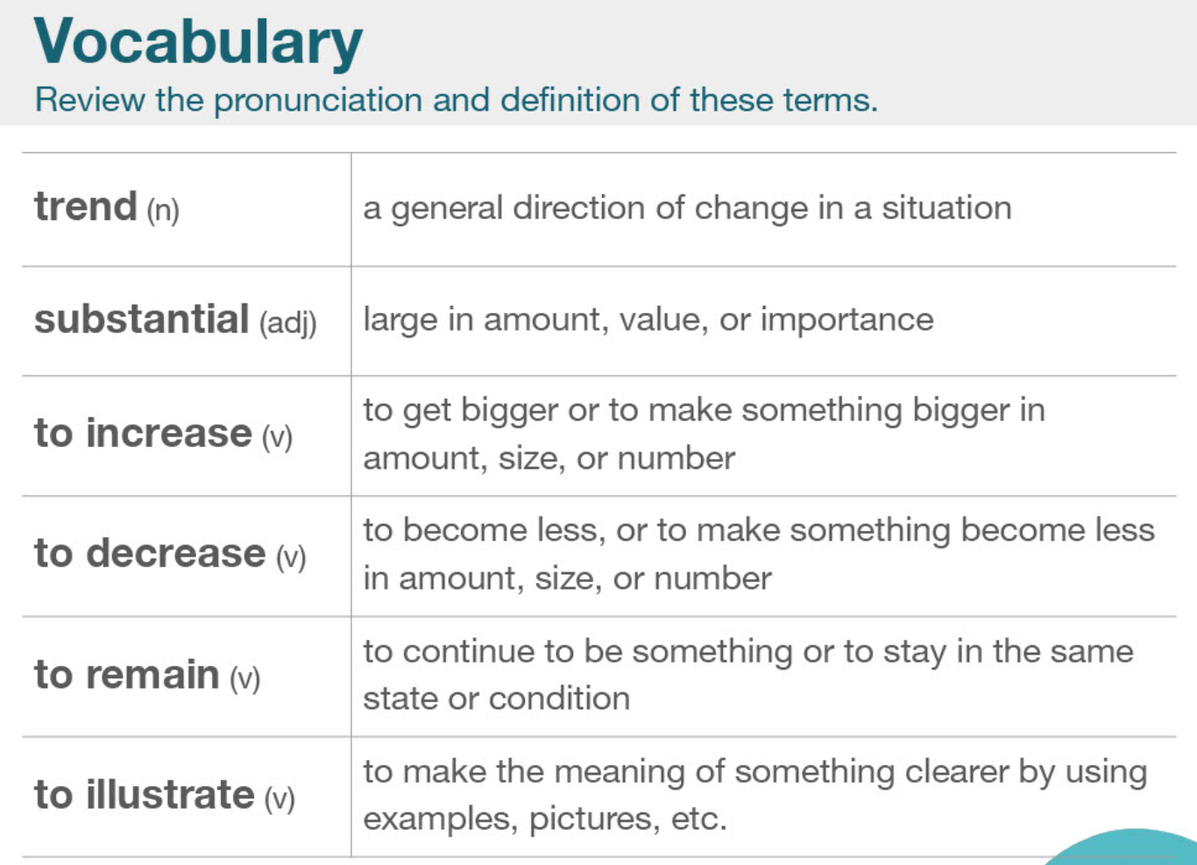

|  |  |  |
| --- | --- | --- |
| Presentation  Graph,  chart,  diagram | /ˌprez(ə)nˈteɪʃ(ə)n/  /ɡrɑːf/ /tʃɑːt/  /ˈdaɪəɡræm/ | the activity of formally presenting something (as a prize or reward);  a drawing intended to explain how something works; a drawing showing the relation between the parts |
| Trend  Trend analysis | /trend/  [tendency](javascript:;) [tide](javascript:;) [direction](javascript:;) | A general direction of change in a situation |
| substantial | /səbˈstænʃ(ə)l/ | won by a substantial margin  large in amount, value, or importance |
| To increase | Raising, growth, gain,  Enhancement;  Improve, accelerate;  Add, boost  incline | To get bigger or to make something become less in amount, size, or number |
| To decrease | Reduction, loos;  To cut down, fall off;  Shorten, weaken  decline | In opposite of increase |
| To remain  keep |  | To continue to be something or to stay in the same state or condition |
| To illustrate  Show  demonstrate | /tu ˈɪləstreɪt/ | To make the meaning of something clearer by using example, pictures, etc |
| etc  et cetera | / ˌet ˈsetərə / | So on and so forth |
| units | /ˈjuːnɪts/ | Imperial units 英制单元 |
| **conveys** | /kənˈveɪz/ | Express  show |

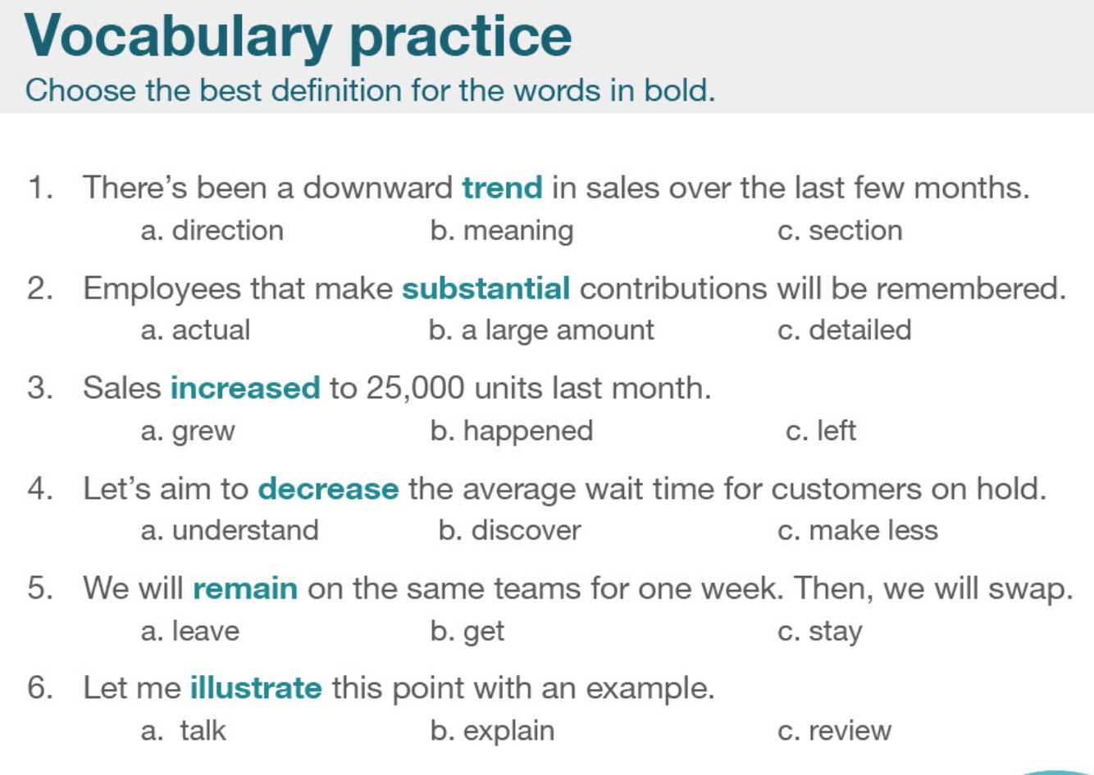

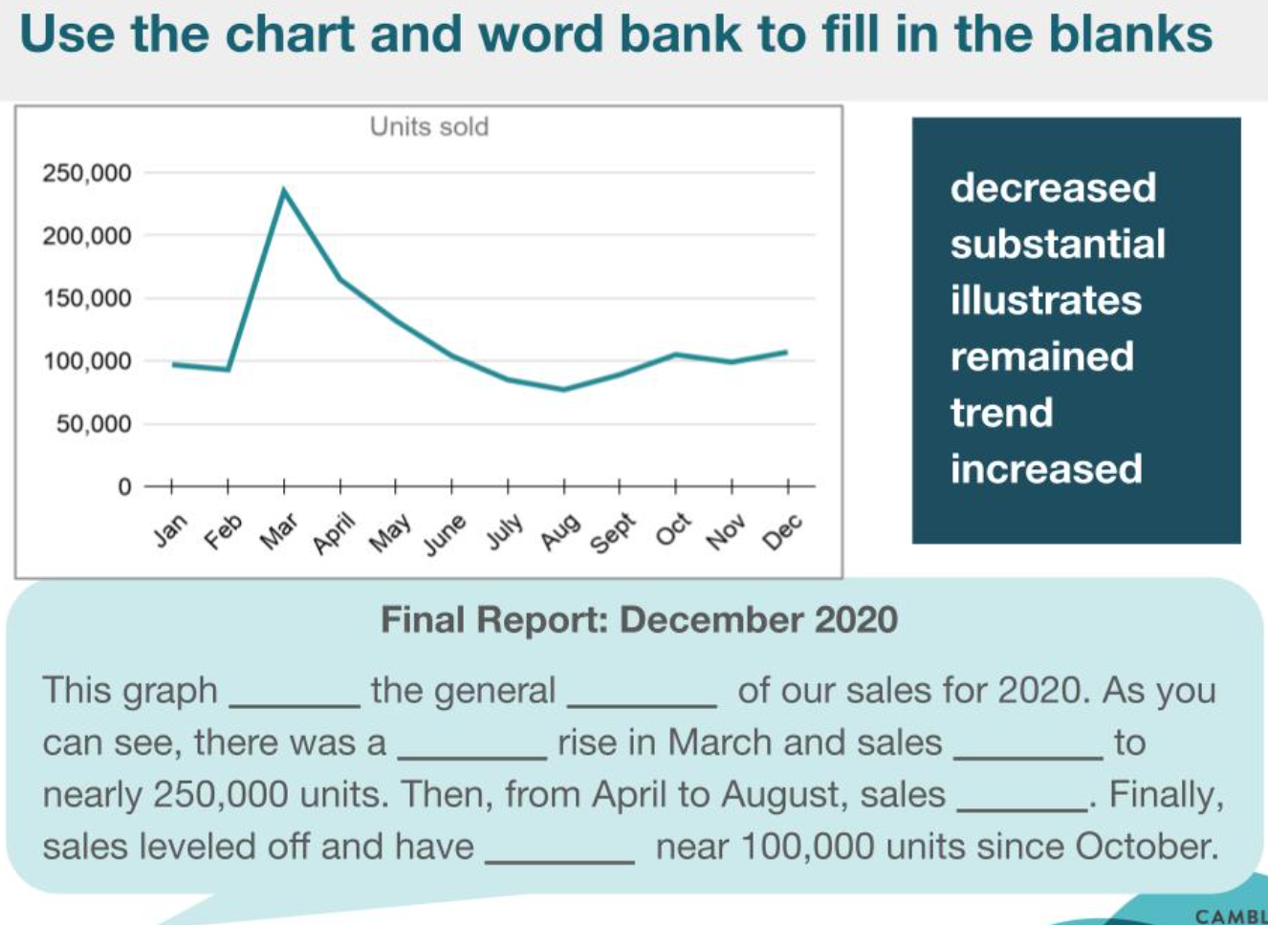

This graph illustrated the general trend of our sales for 2020. As you can see, there was a substantial rise in March and sales increased to nearly 250,000 units. Then, from April to August, sales decreased. Finally, sales leveled off and have remained near 100,100 units since October.

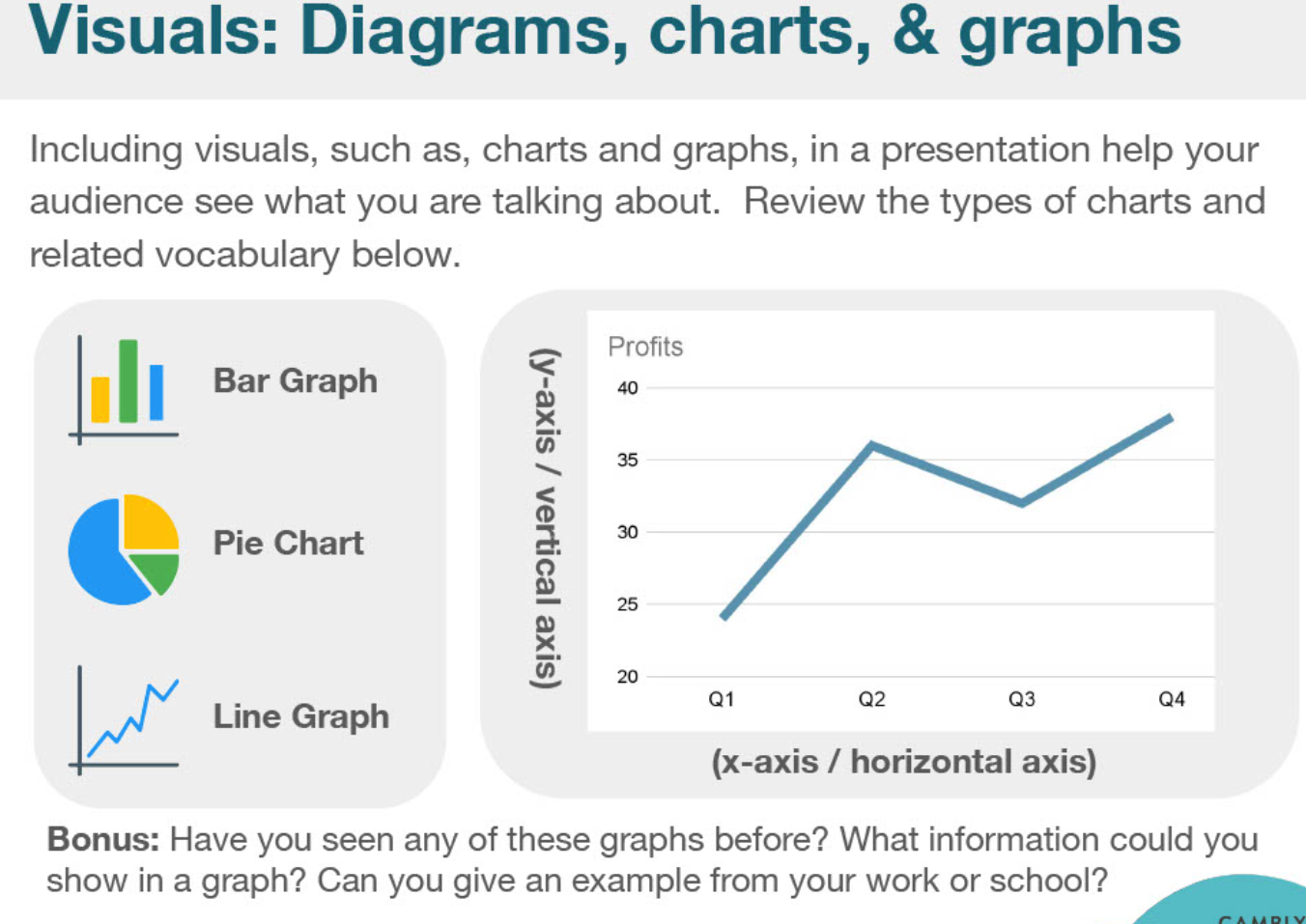

|  |  |  |
| --- | --- | --- |
|  |  | |
| Line graph | A line graph provides a means in which to compare two different types of information through showing how they are **similar** and how they are **differ**. This is performed through the use two lines each representing the two aforementioned pieces of information which are then charted along a numerical scale.  trend | |
| Bar graph | A bar graph is very similar to a line graph in the sense that it is designed to show different values of two or more subjects but instead of using lines it using **horizontal and vertical bars** that represent a different value. There are numbers along the side of a bar graph and they are scales identical to what would be found on a line graph. In a way, this type of graph is somewhat easier to read than a line graph and it **conveys** informational equally as well.  a graphical display of data using bars of **different heights.** | |
| Pie graph | to show differences between two separate subjects although it eschews the common linear style found in the two other graphs.  A pie chart is a very common type of graph that is in the shape of a **circle with the circle representing a collective of 100%.** Then, within the circle smaller **percentage portions** within the 100% will be presented in different colors. It is probably the easiest chart to read and is commonly used in marketing and business presentations. | |
|  |  | |
| Horizontal axis | /ˌhɒrɪˈzɒnt(ə)l/ | Horizontal line/direction  parallel to or in the plane of the horizon or a base line |
| Vertical axis | /ˈvɜːtɪk(ə)l/ | Vertical distribution  something that is oriented vertically;  a vertical structural member as a post or stake |
| Curve  Line, linear  percentage | /kɜːv/  /laɪn/ /ˈlɪniə(r)/  /pəˈsentɪdʒ/ |  |
| Bonus  Annual bonus  Bonus point | /ˈbəʊnəs/ | 奖金，津贴，红利；意外收获，额外好处  anything that tends to arouse;  an additional payment (or other remuneration) to employees as a means of increasing output |
| **Visual**  **Visualize**  **visualization** | /ˈvɪʒuəl/  /ˈvɪʒuəlaɪz/ /ˌvɪʒuəlaɪˈzeɪʃn/ | Data visualization  Flow visualization |
| Diagram  Chart  graph | /ˈdaɪəɡræm/ | Sequence diagram |
| **proficiency** | /prəˈfɪʃ(ə)nsi/ | Proficiency test熟练测验 |
| **Valid documentation** |  | 有效证件  Valid identity documents |
| **certification** | /ˌsɜːtɪfɪˈkeɪʃ(ə)n/ | Quality certification 质量认证 |

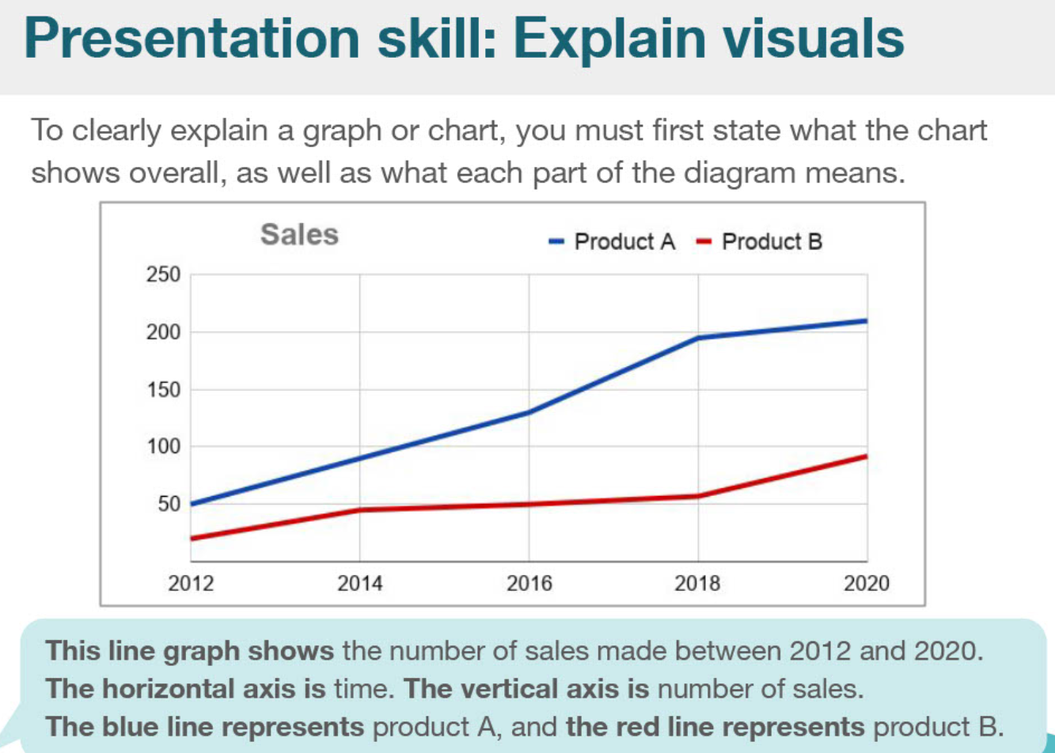

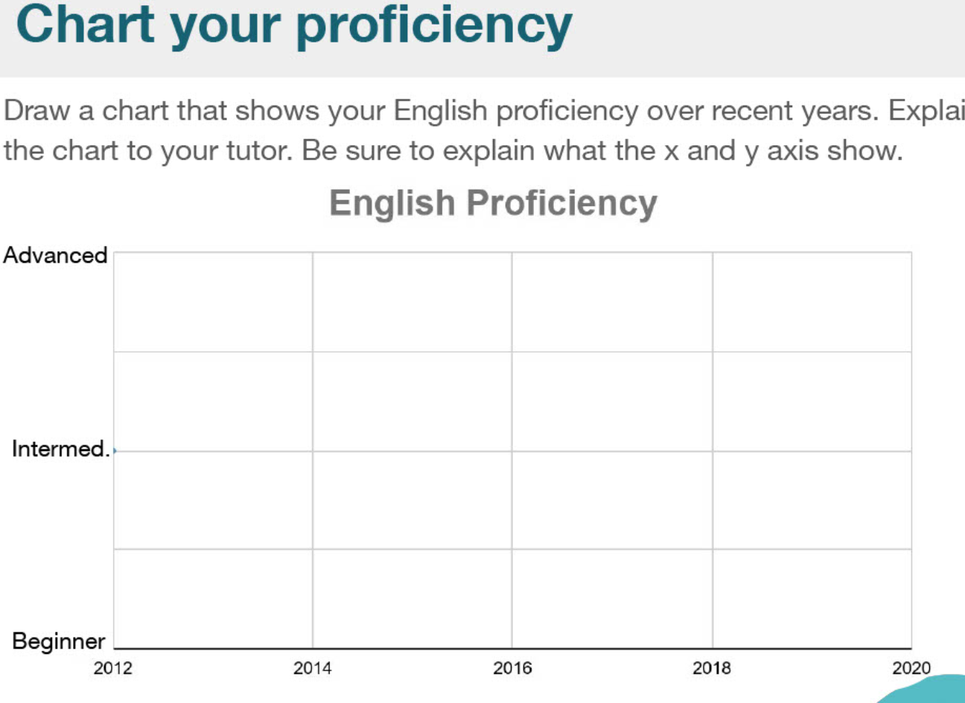

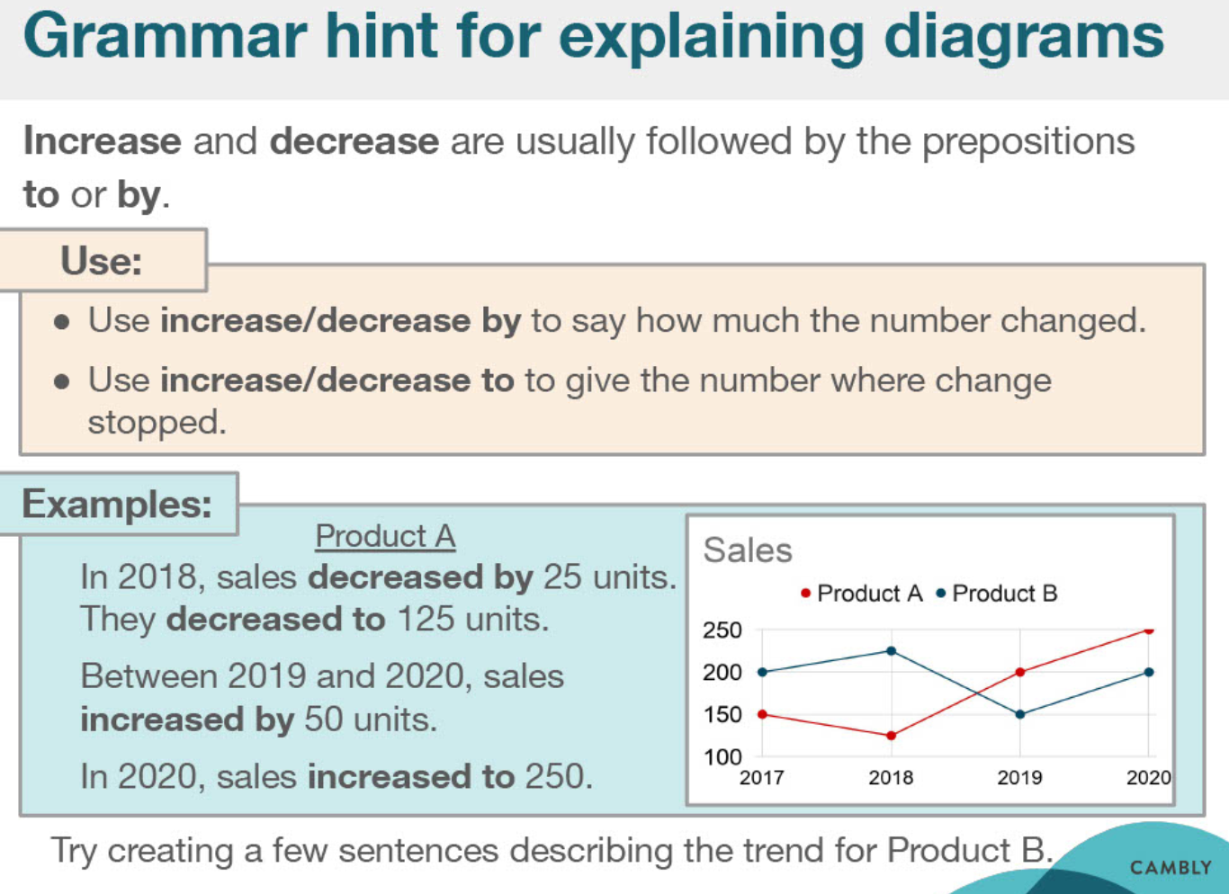

|  |  |  |
| --- | --- | --- |
| hint | /hɪnt/ | an indirect suggestion |
| prepositions | /ˌprepəˈzɪʃən/ | 介词；系词  a function word that combines with a noun or pronoun or noun phrase to form a prepositional phrase that can have an adverbial or adjectival relation to some other word |
| per se |  | In oneself  with respect to its inherent nature |
| inherent |  | Inherent quality  Inherent characteristic |

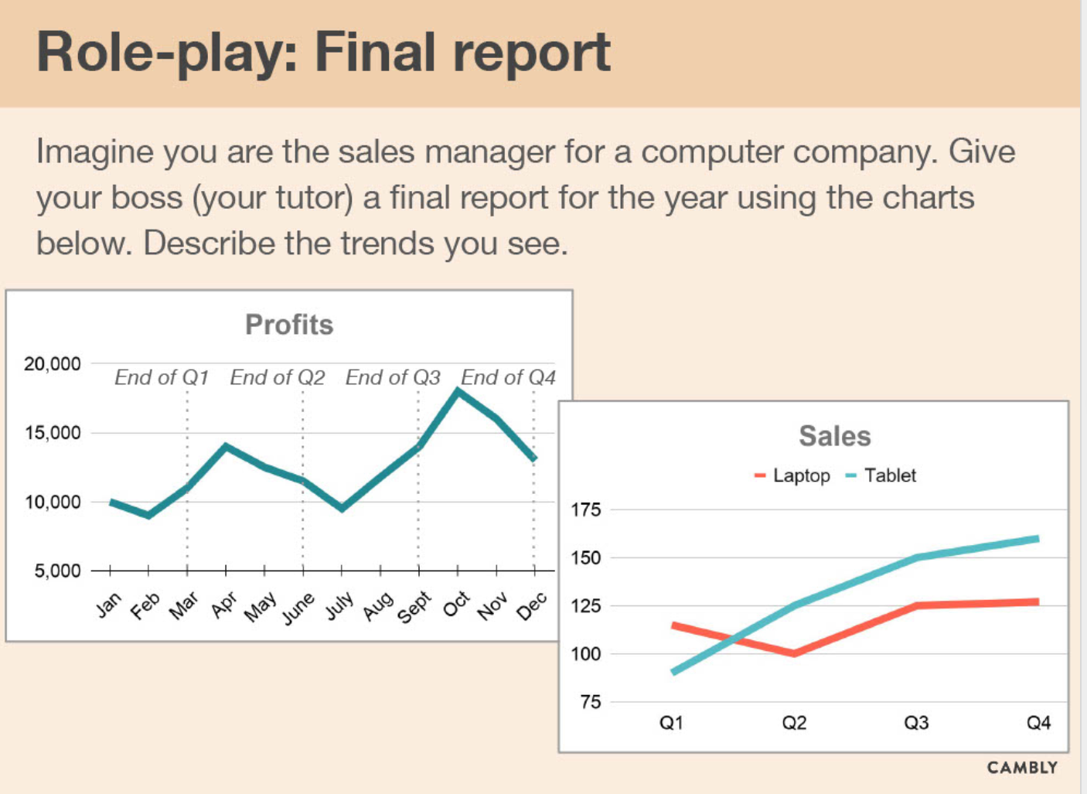

# Sale pitch

## notes

|  |  |  |
| --- | --- | --- |
| Reliable / trust  Confident / courage | /rɪˈlaɪəb(ə)/  /ˈkɒnfɪdənt/ | worthy of reliance or trust  reliable quality  reliable data/information |
| etc  etcetera | /etˈsetərə/ | et-ce-te-ra |
| Advertising | /ˈædvətaɪzɪŋ/ | a public promotion of some product or service； the business of drawing public attention to goods and services  advertising agency/industry  advertising campaign |
| current | /ˈkʌrənt/ | 电流 electrical  Direct current  Alternating current |
| Bias 偏见  Prejudice 偏见  favour 偏爱 | /ˈbaɪəs/  /ˈpredʒədɪs/  /ˈfeɪvə(r)/ | Bias current  a partiality that prevents objective consideration of an issue or situation |
| market share |  |  |
| 70% = seventy per cent |  |  |

|  |  |  |
| --- | --- | --- |
| Benefit  Profit  Be good for  advantage | /ˈbenɪfɪt/ | Something that helps you or gives you an advantage |
| Impact  Affect  Influence  impression | /ˈɪmpækt/ | The effect that a person, event, or situation has one someone or something |
| priority | /praɪˈɒrəti/ | Give priority to / top priority  Something that is very important and must be dealt with before other things |
| Primary  Elementary  Major  Main  leading | /ˈpraɪməri/ | Primary school / primary market  one of the main flight feathers projecting along the outer edge of a bird's |
| To assess  Evaluate | /əˈses/  /ɪˈvæljueɪt/ | To make a judgement about the quality, size, or value, etcetera |
| To convince  Believe  Reliable  assure | /kənˈvɪns/ | To persuade someone or make them certain |

|  |  |  |
| --- | --- | --- |
| **Audience**  Spectator  Listener  Reader  interview | /ˈɔːdiəns/ | a gathering of spectators or listeners at a (usually public) performance;  the part of the general public interested in a source of information or entertainmen |
| presentation | /ˌprez(ə)nˈteɪʃ(ə)n/ | the activity of formally presenting something (as a prize or reward);  a show or display; the act of presenting something to sight or view |
| Assumption  Conception  Perhaps  if | /əˈsʌmpʃn/ | Fundamental assumption  a statement that is assumed to be true and from which a conclusion can be drawn |
| **Fundamental**  **Essential**  **Basic**  **Organic**  **Primary**  **elementary** | /ˌfʌndəˈment(ə)l/  /ɔːˈɡænɪk/  /ˌelɪˈmentri/ | Fundamental principle  Fundamental research  serving as an essential component |
|  |  |  |
|  |  |  |

|  |  |  |
| --- | --- | --- |
| **Potential** users  Possible  Probability  feasible | /pəˈtenʃ(ə)l/ | the inherent capacity for coming into being  market potential  develop potential |
| Interested **investor** | /ɪnˈvestə(r)/ | Institutional investor / foreign investor  Investor confidence  someone who commits capital in order to gain financial returns |
| **Financial**  **economic** | /faɪˈnænʃ(ə)l/ | Financial crisis  involving financial matters |
| **clients** | ˈklaɪənts/ | Our clients  Client side; client service  someone who pays for goods or service |

|  |  |  |
| --- | --- | --- |
| Human Resources department | HR | Human Resource department |
| Hiring  tenancy  Employment  engaging | /ˈhaɪərɪŋ/  /ˈtenənsi/  /ɪnˈɡeɪdʒɪŋ/ | 1.the new hires need special training  a newly hired employee  2.he signed up for a week's car hire  the act of hiring something or someone |
| Crucial=important  critical | /ˈkruːʃ(ə)l/ | **The crucial experiment** |
| Critical thinking | /ˈkrɪtɪk(ə)l/ |  |

## Lesson slides and notes

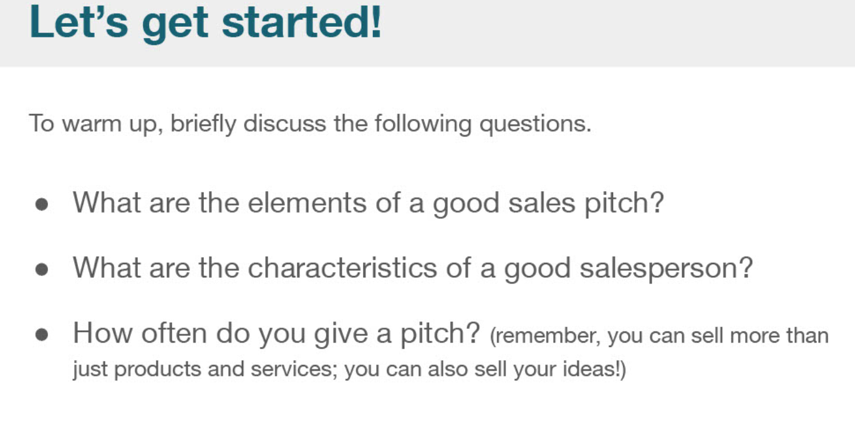

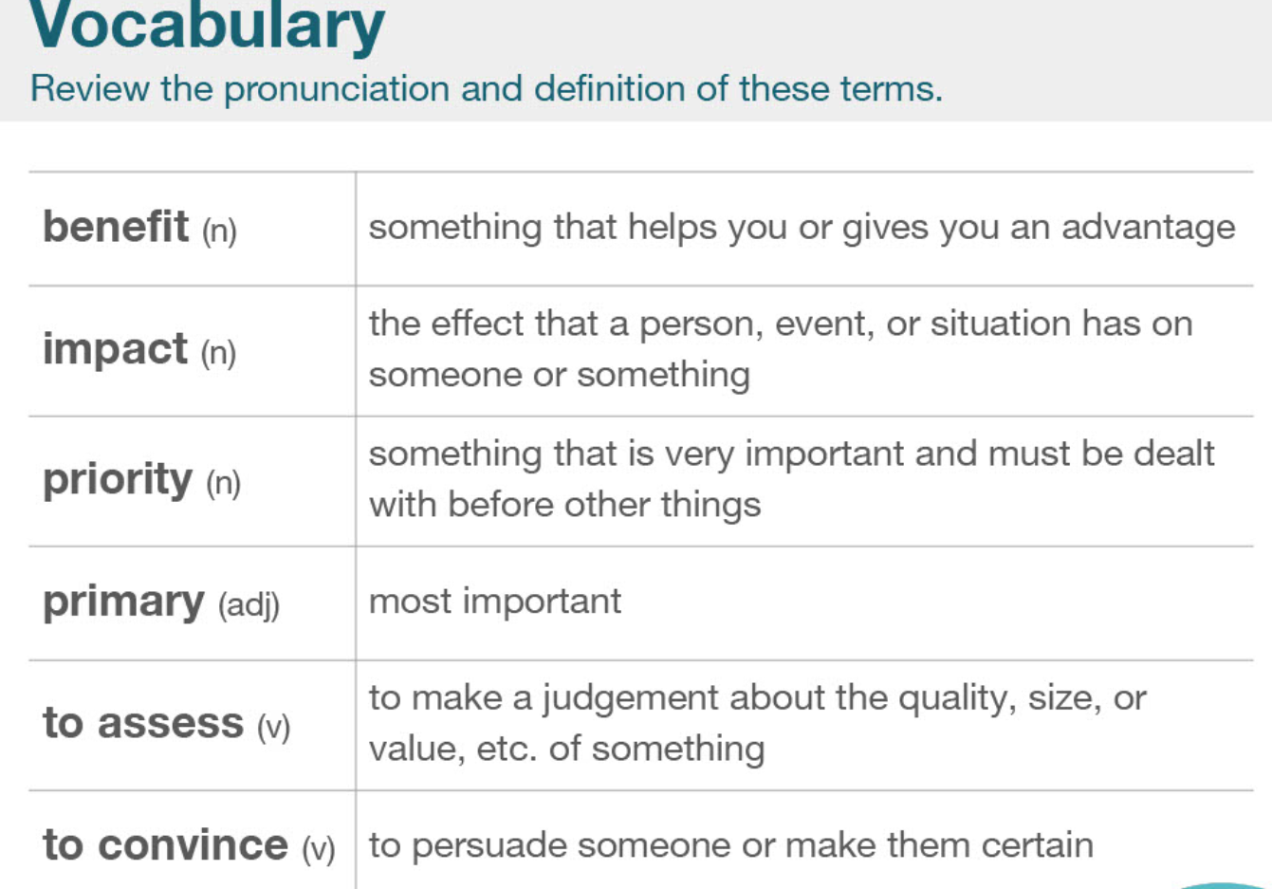

|  |  |  |
| --- | --- | --- |
| Benefit  Profit  Be good for  advantage | /ˈbenɪfɪt/ | Something that helps you or gives you an advantage |
| Impact  Affect  Influence  impression | /ˈɪmpækt/ | The effect that a person, event, or situation has one someone or something |
| priority | /praɪˈɒrəti/ | Give priority to / top priority  Something that is very important and must be dealt with before other things |
| Primary  Elementary  Major  Main  leading | /ˈpraɪməri/ | Primary school / primary market  one of the main flight feathers projecting along the outer edge of a bird's |
| To assess  Evaluate | /əˈses/  /ɪˈvæljueɪt/ | To make a judgement about the quality, size, or value, etcetera |
| To convince  Believe  Reliable  assure | /kənˈvɪns/ | To persuade someone or make them certain |
| Benefit  Profit  Be good for  advantage | /ˈbenɪfɪt/ | Something that helps you or gives you an advantage |
| Impact  Affect  Influence  impression | /ˈɪmpækt/ | The effect that a person, event, or situation has one someone or something |
| priority | /praɪˈɒrəti/ | Give priority to / top priority  Something that is very important and must be dealt with before other things |
| Primary  Elementary  Major  Main  leading | /ˈpraɪməri/ | Primary school / primary market  one of the main flight feathers projecting along the outer edge of a bird's |
| To assess  Evaluate | /əˈses/  /ɪˈvæljueɪt/ | To make a judgement about the quality, size, or value, etcetera |
| To convince  Believe  Reliable  assure | /kənˈvɪns/ | To persuade someone or make them certain |

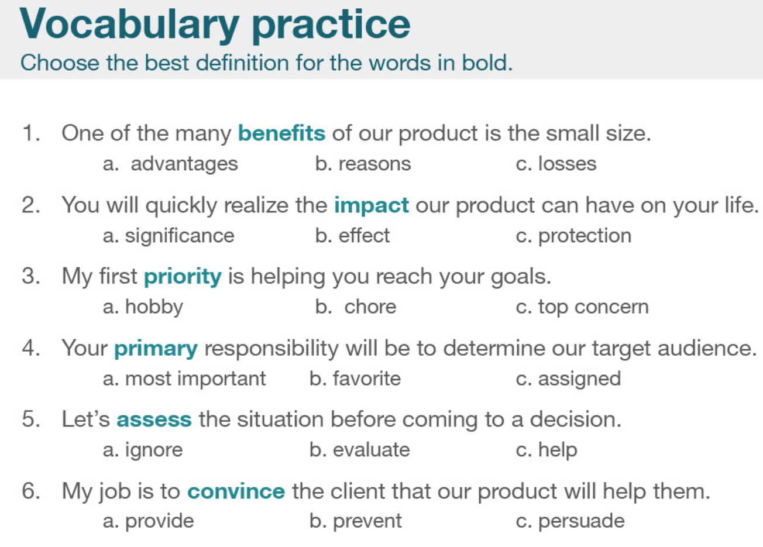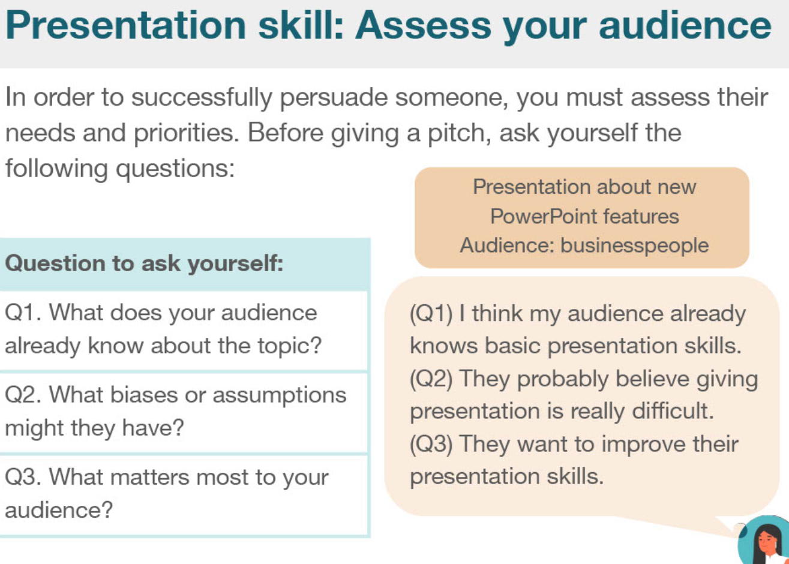

|  |  |  |
| --- | --- | --- |
| **Audience**  Spectator  Listener  Reader  interview | /ˈɔːdiəns/ | a gathering of spectators or listeners at a (usually public) performance;  the part of the general public interested in a source of information or entertainmen |
| presentation | /ˌprez(ə)nˈteɪʃ(ə)n/ | the activity of formally presenting something (as a prize or reward);  a show or display; the act of presenting something to sight or view |
| Assumption  Conception  Perhaps  if | /əˈsʌmpʃn/ | Fundamental assumption  a statement that is assumed to be true and from which a conclusion can be drawn |
| **Fundamental**  **Essential**  **Basic**  **Organic**  **Primary**  **elementary** | /ˌfʌndəˈment(ə)l/  /ɔːˈɡænɪk/  /ˌelɪˈmentri/ | Fundamental principle  Fundamental research  serving as an essential component |
|  |  |  |
|  |  |  |

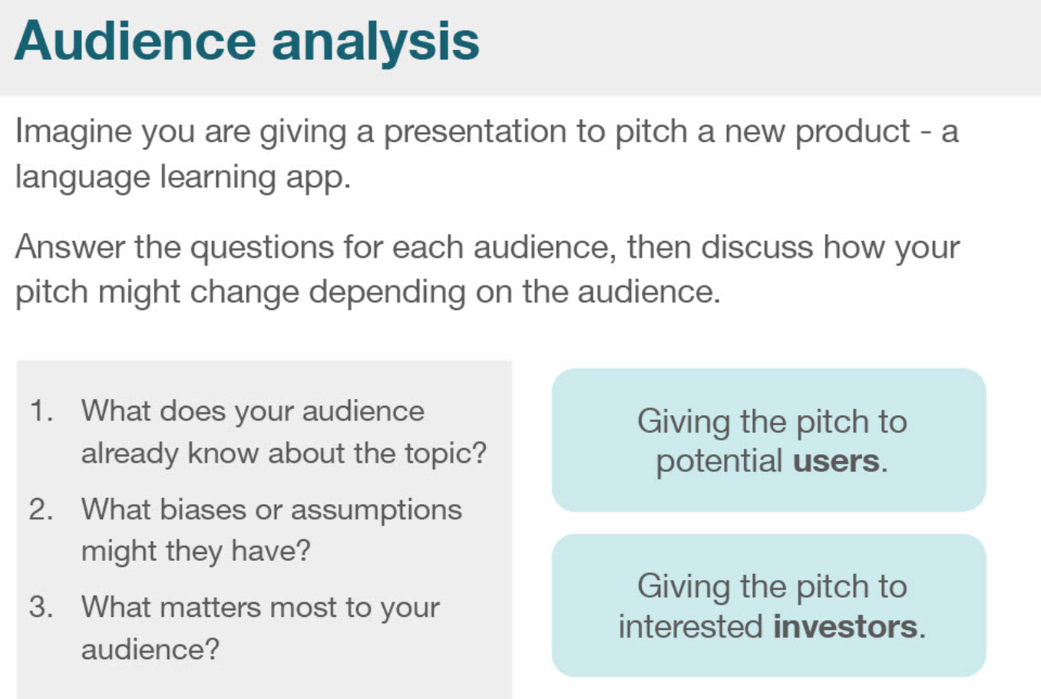

|  |  |  |
| --- | --- | --- |
| **Potential** users  Possible  Probability  feasible | /pəˈtenʃ(ə)l/ | the inherent capacity for coming into being  market potential  develop potential |
| Interested **investor** | /ɪnˈvestə(r)/ | Institutional investor / foreign investor  Investor confidence  someone who commits capital in order to gain financial returns |
| **Financial**  **economic** | /faɪˈnænʃ(ə)l/ | Financial crisis  involving financial matters |
| **clients** | ˈklaɪənts/ | Our clients  Client side; client service  someone who pays for goods or service |

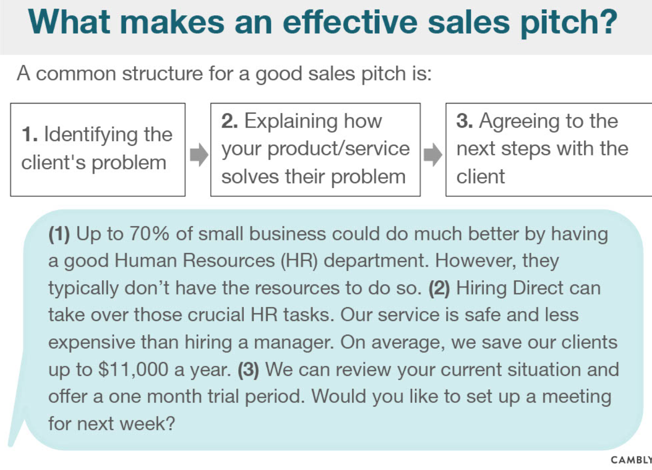

|  |  |  |
| --- | --- | --- |
| Human Resources department | HR | Human Resource department |
| Hiring  tenancy  Employment  engaging | /ˈhaɪərɪŋ/  /ˈtenənsi/  /ɪnˈɡeɪdʒɪŋ/ | 1.the new hires need special training  a newly hired employee  2.he signed up for a week's car hire  the act of hiring something or someone |
| Crucial=important  critical | /ˈkruːʃ(ə)l/ | **The crucial experiment** |
| Critical thinking | /ˈkrɪtɪk(ə)l/ |  |

